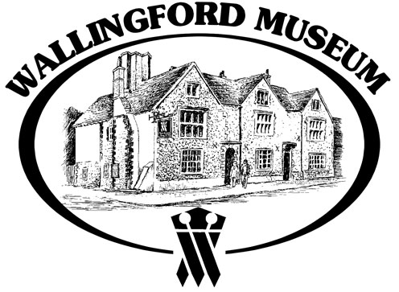

Wallingford Museum News

Wallingford Museum opens from Tuesday March 3rd 2026. Please look at the website for opening times. https://www.wallingfordmuseum.org.uk

We look forward to another fabulous event with the return of the Saxons to the museum!
‘Meet the Anglo-Saxons!” An event for all the family. This is a drop in event running from 11am to 4pm. Saturday 11th April 2026. Please note that normal museum admission fee applies, adults £6 and accompanied children free.

Come and discover more about the day to day lives of the people who lived and worked within the Anglo-Saxon burh of Wallingford. Weaving to writing, wheels to warfare, how would you manage without electricity, plastic materials or modern transport?

The museum offers three intriguing and different exhibitions this year, something for all of the family.

‘Through Wallingford’s Workhouse Door
Explore, Experience, Endure’
This exhibition offers families, especially for those children learning about the Victorians, to discover history on their door step!
Visitor's are invited to cross the threshold of the Workhouse and discover what life was really like for the men, women, and children who passed through its doors — not by choice, but through necessity.
'Agatha Christie's Wallingford'
Wallingford Museum will mark the 50th anniversary year of Dame Agatha Christie's death at Winterbrook House, with a special exhibition highlighting aspects of life in Wallingford during her later life.
The final exhibition is ‘Digging for Wallingford - Archaeology at Work’ - discover more
about the work of the TWHAS archaeologists.

The Wallingford Historical and Archaeological Society (TWHAS)
March 11 (Weds) - Andy Hood: “On-going excavations at Winterbrook and New Barn Farm by Foundations Archaeology, with an update on the Cholsey Roman villa report”
https://www.twhas.org.uk/meetings-programme.html for the 2026 talks programme.

Sue Wright
Wallingford Museum

